To create an electronic PM data sheet:

Navigate to the PM Schedule on the CD… Planned Maintnance – Planned Maintenance Schedules…

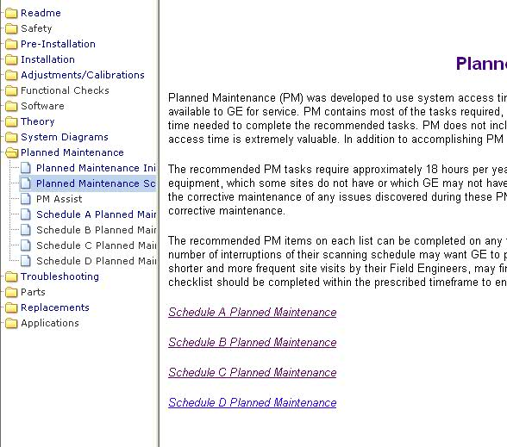

Right-click each schedule and select “Save Target as…” and save as and Excel (.xls) document with whatever name you wish… ex: Schedule C Planned Maintenance.xls

(save it somewhere you can find it… such as the desktop)

Double click the icon to open the Planned Maintenance schedule…

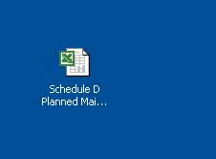

This should launch the Maintenance Schedule as an Excel Spreadsheet. (Click OK to any messages )

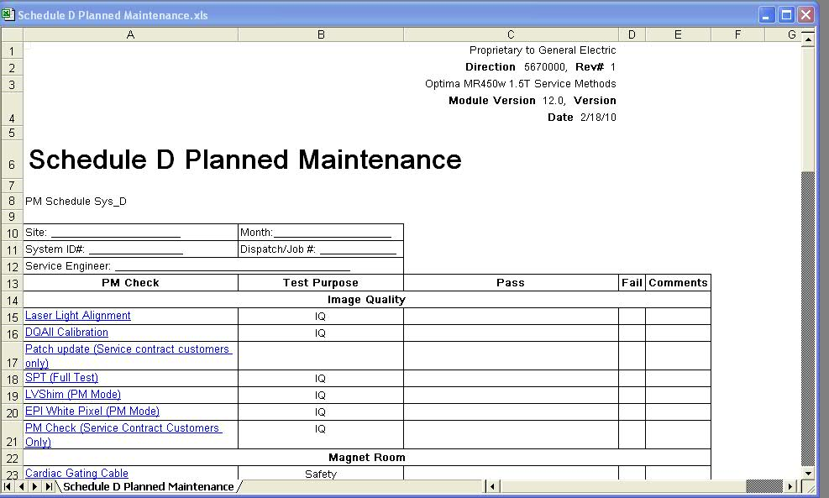
The excel file can be filled out, saved, printed, stored, or emailed.

